This is a sample that earns a perfect score. It should be a helpful sample for you. Please do not write on this document.

International institutions warn of growing trade protection in developed countries
(1) The World Trade Organization (WTO) and the International Monetary Fund (IMF) have warned· that the deepening global recession might lead some countries to abandon their free trade commitments and slide into trade protection. Even though the world’s largest economies had agreed to avoid the mistakes of the Great Depression, when protectionism clearly made the situation worse, there was growing concern that trade wars were likely to break out.

(2) Amid claims of unfair trade through subsidized exports, both the USA and the EU are planning to introduce tariffs on a range of products imported from Asian countries. These products include frozen sea food from Vietnam and Thailand, tires and car radios from China, and car accessories from Malaysia. Apart from tariffs, the EU is imposing non-tariff barriers on certain foodstuffs imported from Africa and India through the introduction of stricter rules for health and hygiene.

(3) A leading economist at the Free Trade Association claimed that the proposed measures would be counter-productive and would only spark retaliation from the Asian countries with the consequence that trade volumes would fall. A trade war would simply plunge the global economy into a deeper recession and there would be no winners.

(4) Although some EU and American manufacturers support the measures, a majority are strongly opposed because the tariffs will raise their production costs and reduce their competitiveness. Consumer groups also oppose the proposals for trade restrictions for fear that they will lead to higher retail prices.

(5) It is estimated that a 10% increase in tariffs would result in a cost of $30 billion to the global economy in lost production and trade.

a) (i) Define the term tariff indicated in bold in the text. (paragraph 2) (2 marks)

(ii) Define the term recession indicated in bold in the text. (paragraph 3)
(2 marks)

b) Using an appropriate diagram, explain why export subsidies are an example of unfair trade. (paragraph 2)

(4 marks)

c) Using an appropriate diagram, explain why "a trade war would simply plunge the global economy into a deeper recession". (paragraph 3)

(4 marks)

d) Using information from the text and your knowledge of economics, evaluate the consequences of trade protection for the global economy.

(8 marks)
Answer:
a) (i) A tariff is a tax on imports which raises their price and reduces quantity demanded.

(ii) Recession is associated with the downturn of the trade cycle with at least two consecutive quarters of negative growth.

b) Export subsidies give the exporters an unfair advantage because the subsidy artificially reduces their costs of production. The effect is shown in diagram 1 where, as a result of the subsidy, the supply shifts to the right to S1 and the price is now lower at Ps. Whereas before the subsidy the export price was above the world price, after the subsidy it falls below the world price Pw and the exports may achieve an artificial comparative advantage.

Diagram 1

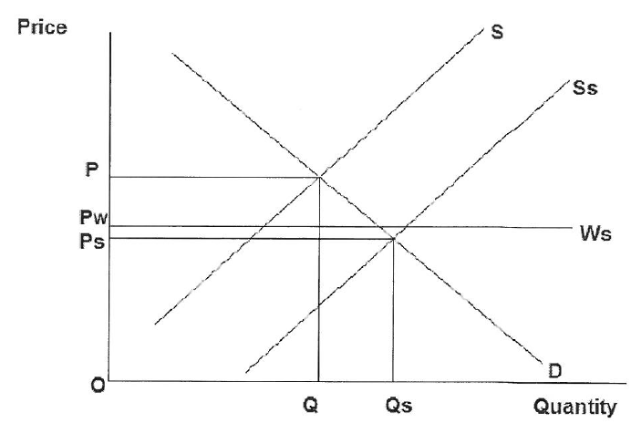

c) A trade war would result in increased restrictions on trade so that countries would be importing less and exporting less. This would lead to a reduction in the (X-M) component of Aggregate Demand (AD) and as a result AD would shift to the left to AD1 as shown in Diagram 2.

Diagram2
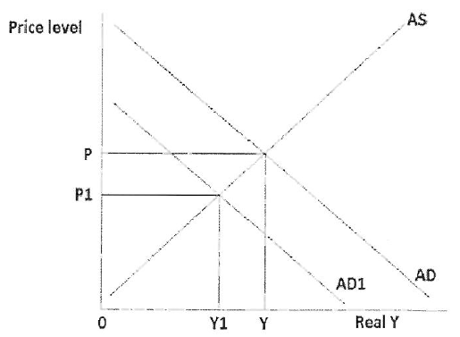

The decrease in AD to ADl will lead to a fall in real output, income and employment to Yl. This could slow down growth and deepen the world recession because as income falls in one country, demand for imports falls and this amounts to a fall in exports of other countries thus creating a deflationary spiral.

d) Increased trade protection would have a major impact on the global economy. Several important effects are identified in the text. Paragraph 1 identifies the concerns of the WTO which is an international institution that promotes free trade. Together with the IMF, it fears that trade wars could ensue and the world economy could suffer a global recession similar to what happened in the depression of the 1930's. This fear is also expressed in paragraph 2 and it would seem that the negative opinion of trade protection is quite widely held. Paragraph 5 identifies a specific cost associated with lost output and it is likely that the poorest countries would be worst affected by a global slowdown. Potential stakeholders, such as producers, who might gain from trade protection, are only mentioned in paragraph 4, but, even then, it is claimed that a majority of manufacturers oppose tariffs because they would lead to an increase in production costs. Only producers who are in direct competition with cheap imports are likely to favor trade protection.
Most of the products mentioned as candidates for protection in paragraph 3 are used to produce other goods such as cars so that tariffs would simply increase production costs for car manufacturers.
Overall, the text is heavily weighted in favor of free trade and an examination of the effects on tariffs would help to evaluate this view. Diagram 3 shows the effects of a tariff imposed on a good that could be imported at the world price of Pw.

Diagram3

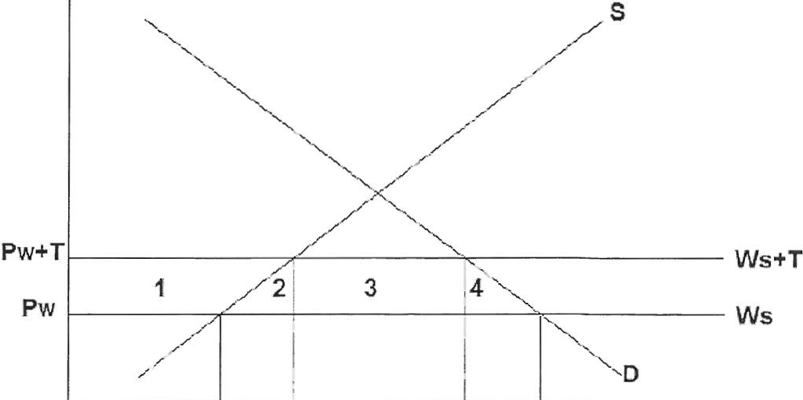
Price

0
Q2 Q3 Q4 Q1 Quantity

The tariff increases the world price to Pw + T and as a result the volume of imports falls from Q1-Q2 to Q4-Q3. This means that foreign producers are selling less and so world output and consumption falls, thus supporting the claims made in the text. In addition, the domestic consumers will lose a part of their consumer surplus equal to the combined areas 1+2+3+4, which supports the claim in paragraph 4 that consumers are against trade protection.
Furthermore, tariffs and non-tariff barriers could lead to retaliation as mentioned in paragraph 3 and this could cause a dangerous breakdown in international trade relations.
Overall, it would appear that the consequences of increased trade protection would be damaging for the global economy in the long run and the analysis of the tariff diagram supports the views expressed in the text. As with the 1930's, protectionist policies would be a major threat to the success of the global recovery.

