INTERNATIONAL ECONOMICS Why do Countries Trade?

What are the benefits of trade?

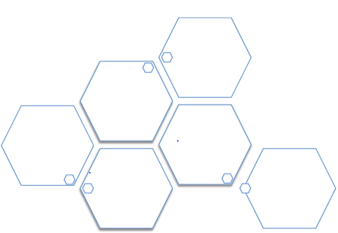

Free Trade and Protectionism

Define protectionism:

Why do countries engage in protectionism?

What is a tariff?

In the space below, draw a diagram of how a tariff works and explain it:

On your diagram, make sure you illustrate and explain the following:

- economic rent
- deadweight loss
- revenue to taxpayer
- extra revenue gained by domestic producers

What is a subsidy?

In the space below, illustrate and explain the imposition of a subsidy on a product.

On your diagram, make sure you illustrate and explain the following:

- deadweight loss
- cost of subsidy for government
- extra revenue for domestic producers
- how revenue for foreign companies has fallen

What is a quota/’voluntary export restraint’?

In the space below, illustrate and explain the imposition of a quota on a product.

On your diagram, make sure you illustrate and explain the following:

- deadweight loss
- economic rent
- revenue for foreign companies allowed to export as part of agreement
- extra revenue for domestic producers

What is the World Trade Organization?

What are its aims?

What does the phrase ‘dumping’ mean?

In the table below, consider some of the arguments regarding the
WTO’s achievements?

‘The WTO is a great success’: ‘The WTO is a dismal failure’:

Economic Integration:

What is ‘globalization’?

What are multinational corporations (MNC’s)? Suggest some examples.

Define a trading bloc:

Trading blocs can vary depending on the level of integration involved. Complete the table below with a short summary of each type of trading bloc and examples:

Type of trading bloc: | Explanation: | Examples:
Preferential trading area
Free trade area
Customs union
Common market
Economic and monetary union

Exchange Rates

Explain the concept of a fixed exchange rate:

Explain the concept of a floating exchange rate: Explain the concept of a managed exchange rate: What factors could affect the demand for a currency?: What factors could affect the supply of a currency?: Complete the table below with relevant points:

Advantages of a high exchange rate: | Disadvantages of a high exchange rate:
Advantages of a low exchange rate: | Disadvantages of a low exchange rate:

How can the government intervene in currency markets?

Balance of Payments

The current account is made up of:

-
-
-

The capital account includes:

What are the consequences of a current account deficit?

What are the consequences of a surplus on the current or capital account?

Governments can correct a persistent current account deficit by:

1. Expenditure-switching policies:

2. Expenditure-reducing policies:

