IB Economics  Mrs. Shackett  Planet Money T-Shirt Concept Map Assignment |  |  | Name ________________________________
Hopefully everyone enjoyed the t shirt series. In order to make connections between the content we have learned this year, I am assigning a guided discussion with a cumulative concept map as the product you will share and submit at the end of class. Teams are listed below. The student in bold is the leader of the concept map portion of the day because I know they have completed the same task in Dr. Neal’s class. S/he is not necessarily in charge of the entire group or discussion.

Carla Baker  Kate Fiore  Joe Mah  Faith Pacheco | Nick Deidel  Charles Huang  Elzia Sekou  Alex Singh | Kira Emsbo  Ethan Drews  Casey Mauldin  Kate Oehm |  | Caleb Matteson  Etti Cooper  Taage Dressel-Martin  Nick Ochoa

Step 1: Take 10-15 minutes to share the most memorable parts of the series. Find the podcast titles below. What did you like? What was dry? What did the producers leave out? What questions do you have after listening to the series?
- Where the Planet Money T-Shirt Began
- Love, Betrayal, and the Planet Money T-Shirt
- The Last T-Shirt in Colombia
- Richard Nixon, Kimchi, and the First Clothing Factory in Bangladesh
- The Humble Innovation at the Heart of the Global Economy
- A Shirt, a Meat Grinder, and the Book of Everything
- The Afterlife of a T-Shirt
- Adding Up the Cost of the Planet Money T-Shirt

Step 2: Make connections to economic concepts we have studied so far this year, focusing more on international concepts than micro and macro. Record your connections on a concept map. Use butcher paper or a website like bubbl.us to create the concept map. The map will be shared and submitted at the end of the block.
Microeconomics | Macroeconomics | International Economics
- Competitive markets: Demand and supply  - Elasticity  - Government intervention  - Market failure | 2.1 The level of overall economic activity  2.2 AS/AD  2.3 Macroeconomic objectives  2.4 Fiscal policy  2.5 Monetary policy  2.6 Supply-side policies | 3.1 International trade: free trade and protectionism
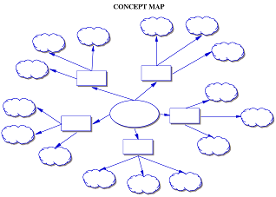
Here are some questions to extend the quality of your connections:
- What are the features of the process?
- When is the process implemented?
- What conditions are necessary for the process to work?
- In what ways does the process affect progress?
- Evaluate the value of the process to our world.
- Analyze reactions to the process.

