AP Macroeconomics  Mrs. Shackett  Phillips Curve | Name

- Draw AS/AD with long-run equilibrium. Label the price level PL₁ and rGDP as Y₁. Graph the effect on the equilibrium price level and rGDP if there is a decrease in AD. Label the equilibrium price level and rGDP after the decrease in AD as PL₂ and Y₂.
- What happens to each of the following in the short run?
Real GDP ______________________
The unemployment rate ______________________
The price level ______________________

Real wages ______________________

- Draw a graph of a short-run Phillips curve. Make sure you label your axes correctly! You will plot PL₁ and PL₂ along with their corresponding unemployment rates. There are no numbers for PL₁ and PL₂; just plot PL₁ at some level and then plot PL₂ either above or below it. Then select some unemployment rate (U₁) to go with PL₁ and then plot U₂ either above or below U₁ as shown in the graph above.

- Draw AS/AD with long-run equilibrium. Label the price level PL₁ and rGDP as Y₁. Graph the effect on the equilibrium price level and rGDP if there is an increase in oil prices. Label the equilibrium price level and rGDP after the decrease in AD as PL₃ and Y₃.
- What happens to each of the following in the short run?
Real GDP ______________________
The unemployment rate ______________________
The price level ______________________
Real wages ______________________
- On the short-run Phillips curve you drew before, plot the information and unemployment rates that result when the price of oil increases.
- Suppose the economy is experiencing 2% inflation. News of rising energy costs increase people’s expectations of inflation. Demonstrate the change on a new correctly labeled SRPC graph.

- If the government increases spending, how does it affect inflationary expectations? Explain.

- If people are confident that a new Federal Reserve policy will achieve and maintain price stability, how does it affect inflationary expectations? Explain.

- What will happen to the actual rate of inflation if people expect a higher inflation rate in the future? What will happen to the actual rate of inflation if people expect a lower inflation rate in the future? Explain.

THE LONG-RUN PHILLIPS CURVE
- Draw a graph of the LRPC. Be sure to correctly label the axes and label the point at which the LRPC intersects the horizontal axis. What does the slope of the LRPC indicate about the trade‐off between the inflation rate and the unemployment rate? Explain.

- Use the graph in problem 11 to show the effect on the LRPC if the natural rate of unemployment decrease. What happens to the LRAS when the natural rate of unemployment decreases?
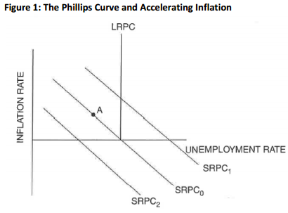
- What change in inflationary expectations is shown by the shift in the short-run Phillips curve from SRPC₀ to SRPC₁ in Figure 1?

- At point A on the graph, the actual inflation is (greater than/less than) the expected rate of inflation, which will cause the SRPC to shift to the (left/right).

- Label point B on the graph where the economy will be in long-run equilibrium after the change in inflationary expectations.
- Label point C on the graph where the economy will be if policy makers attempt to keep the unemployment rate where it was at point A after the change in inflationary expectations. If the government continues to drive down the unemployment rate below the natural rate, what trend will continue to occur? Explain.

