Introduction to Economics

Define the following terms:

• Scarcity:

• Choice:

• Opportunity Cost:

• Utility:

What are the parts of ‘the basic economic problem’?
1.
2.
3.

The factors of production are:
• •
• •

Draw a production possibility curve below for any two goods:

On your diagram above, illustrate the following:

a. a point where all the economy’s resources are being fully utilized, given currently available technology
b. a point where they are not being fully utilized
c. an increase in the productive potential of the economy

What is the difference between positive and normative economics?

What is the difference between a planned economy and a free market economy?

What sort of economy is the US?

What is a ‘transition economy’?

Demand is:
MICROECONOMICS
Demand and Supply

As the price of a good increases, the demand for that good will…………..

Describe the following:

Income effect:

Substitution effect:

What is the difference between normal and inferior goods? Suggest examples of each:

What is the difference between substitute and complementary goods? Suggest examples of each of these pairs:

Suggest and explain some factors that will affect the demand for a product:

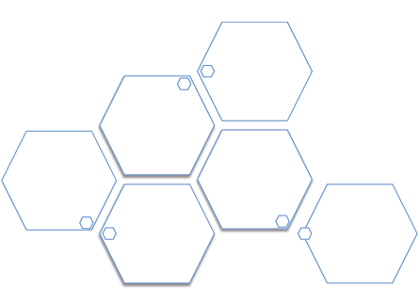

Supply is:
- - -

As the price of a good increases, the supply of that good will…………..

Suggest and explain some factors that will affect the supply of a product:

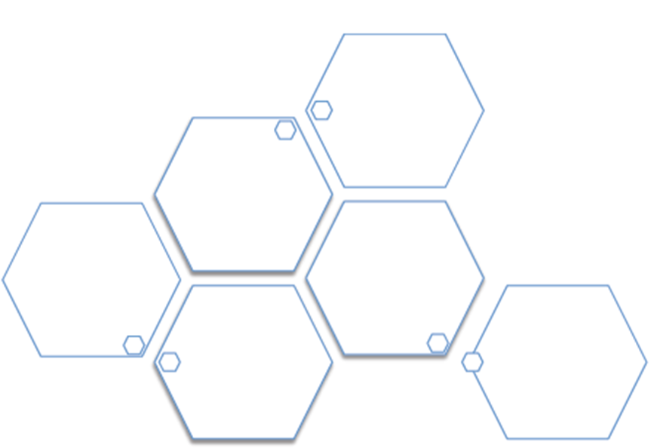

Draw demand and supply diagrams below to illustrate the following:
1. Equilibrium 2. Excess supply 3. Excess demand

Define the following:

a. Minimum price scheme: b. Maximum price scheme:
Draw diagrams below to illustrate each of the situations above:

Define the following:

Consumer surplus:

Producer surplus:

Elasticities

Complete the diagram below with the words ‘unitary’, ‘elastic’, and ‘inelastic’:

Less than 1 1 More than 1

Price Elasticity of Demand

Definition: Formula:
If a good has an inelastic PED and a firm raises its price, the firm’s revenue will…………..

What factors affect the elasticity of a product?

Cross Elasticity of Demand

Definition: Formula:
If XED between two products is negative, they are said to be………………… If XED between two products is positive, they are said to be…………………..

Income Elasticity of Demand

Definition: Formula:
If YED of a product is negative, it is said to be……………………… If YED of a product is positive, it is said to be……………………….

Draw an Engel curve to illustrate what happens to the demand for a product over time as incomes rise:

Price Elasticity of Supply

Definition: Formula:

What factors affect the elasticity of supply of a product?

Taxes and Subsidies

What is the difference between direct and indirect taxes? A specific tax is:
An ad valorem tax is:

Draw a diagram below to illustrate the imposition of an ad valorem tax on a good:

Draw a diagram below to illustrate the imposition of a specific tax on a good:

Illustrate on your diagram:
a. the tax burden/incidence of tax for producers b. the tax burden/incidence of tax for consumers

How would this change if the product became:
1. more elastic:

2. more inelastic:

- - -

Define a subsidy:

Illustrate what happens when a subsidy is introduced for a particular product:

How will elasticity of supply and demand affect your diagram above?

Market Failure

When, in a market/society, it is impossible to make one person better off without making someone else worse off, the situations is referred to as:

Asymmetric information is where: Imperfect competition is where:
How can the government seek to reduce imperfect competition?

Public goods are:
1.
2.

Why will public goods not be provided in a free market economy?

Merit goods are:

Why will merit goods be under-provided in a free market economy?

De-merit goods are:

Why will de-merit goods be over-supplied in a free market economy?

Define the following key terms:

a. marginal social cost:

b. marginal social benefit:

c. marginal private cost:

d. marginal private benefit:

e. external cost:

f. external benefit:

Externalities Situations and Diagrams:
There are four different situations where externalities can occur. For each of these you need to draw a diagram and explain the situation. You should also include examples in your explanation.

1. Negative externalities of production example:
Where the production of a good has negative effects on society

2. Positive externalities of production example:
Where the production of a good has positive effects on society

3. Negative externalities of consumption example:
Where the consumption of a good by an individual harms the rest of society

4. Positive externalities of consumption example:
Where the consumption of a good by an individual benefits the rest of society

