MACROECONOMICS
Measuring National Income

Circular flow of income:
Complete the diagram below by labeling all the lines and the empty boxes:

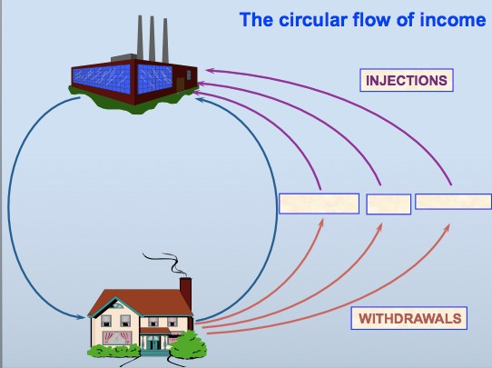

National income is measured by:

1. The output method:

2. The income method:

3. The expenditure method:

Gross national product = GDP + ………………………………………… What is the difference between real and nominal GDP?

What does GDP ‘per capita’ mean?

What are some of the limitations of using GDP as a measure of a country’s standard of living?

Aggregate Demand

AD = C + I + G + (X-M)

For each of these, define and explain it: C:

I:

G:

(X -M):

For each of these, suggest reasons why it would increase/decrease: C:

I:

G:

(X-M):

Demand-Side Policies
Fiscal Policy:
What is an ‘expansionary’ fiscal policy?

What is a ‘contractionary’ fiscal policy?

Monetary Policy:
Two methods of monetary policy are:
1.

2.

Aggregate Supply

What is aggregate supply?

In the space below, draw a short-run aggregate supply curve:

What factors might cause AS to increase or decrease?

Draw a diagram below illustrating the Keynesian Long-run Aggregate
Supply Curve, and explain what it means:

Draw a diagram below illustrating the Neo-Classical Long-run Aggregate
Supply Curve, and explain what it means:

For both long-run diagrams above, using a different color, illustrate an increase in economic growth

What supply-side policies could a government use to shift the AS curve to the right?
Macroeconomic Equilibrium

Draw a diagram illustrating long-run equilibrium from a Keynesian perspective:

- Illustrate an increase in AD on your diagram
- What happens to the price level as AD increases?
- Explain why this occurs below:

Draw a diagram illustrating long-run equilibrium from a Neo-Classical perspective:

- Illustrate an increase in AD on your diagram
- What happens to the price level as AD increases?
- Explain why this occurs below:

Draw two diagrams below illustrating an increase in LRAS- a Keynesian diagram and a Neo-Classical diagram. For each one, explain what the effects of this shift have been on the economy as a whole.

The Business Cycle:

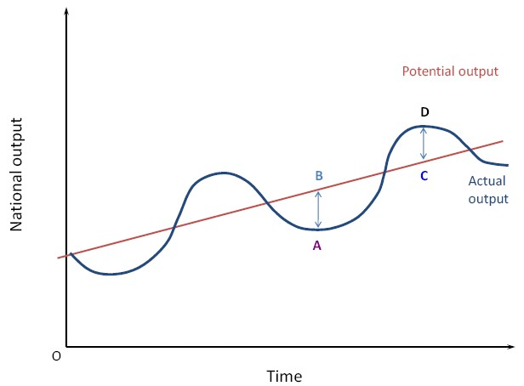

What are the following points on the above diagram?:
1. A:
2. D:
3. Straight line:
4. A-B:
5. C-D:

Inflation and Deflation

Define the following terms:

- inflation:

- deflation:

- disinflation:

What are the negative side-effects of inflation?

Why is deflation bad?

Identify and explain the two causes of inflation:

1.

2.

How does an increase in the supply of money cause inflation?

How can the government control inflation?

Unemployment

What is unemployment?

What are the costs of unemployment to:

- unemployed people:

- society:

- the economy:

Complete the two columns below:

Flows IN:
Flows OUT:

LABOR
FORCE

Describe each of the following types of unemployment:

Real-wage/Classical unemployment:

Demand-deficient/Cyclical unemployment: Equilibrium/Natural unemployment: Frictional unemployment:
Seasonal unemployment:

Structural unemployment:

What solutions could the government put in place to reduce unemployment?
(Note that some of these will be for specific types of unemployment)

‘Crowding out’ is a problem when the government run a budget deficit in an attempt to increase AD. What is it and why is it a problem?

Distribution of Income

Define the following key terms:

Progressive tax: Regressive tax: Proportional tax: Transfer payments: Minimum wage:
What does it mean when a tax is progressive?

How can you criticize the idea of income redistribution?

The Lorenz curve is used to measure:

Household income data is split into:

On this graph, describe each line:

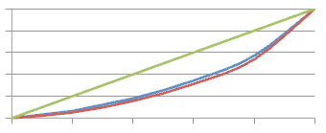
100
Cumulative % of Income
80
60
40
20
0
0 20 40 60 80 100
Cumulative % of Households

What is the Gini index?

How is it measured?

