AP Macroeconomics  Mrs. Shackett  Aggregate Supply | Name

Possible Shapes of Aggregate Supply Curve
Real GDP
Price level
Real GDP
Price level
Real GDP
Price level
AS
AS

AS

- Under what conditions would an economy have a horizontal AS curve?

- Under what conditions would an economy have a vertical AS curve?

- Under what conditions would an economy have a positively sloped AS curve?

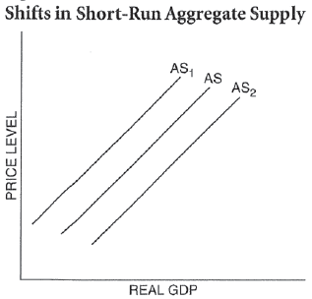
Determine whether each change listed in the table below will cause an increase, decrease, or no change in aggregate supply. Always start with AS.
In column 1, list which component of AS is affected: input prices or productivity.
In column 2, draw an up arrow if the change will cause an increase in AS, a down arrow if it will cause a decrease in AS, and write NC if it will not change AS.
In column 3, write the number of the AS curve after the change.
Change | Determinant of AS | Change in AS | Resulting AS curve
- Unions are more effective, so wage rates increase.
- OPEC successfully increases oil prices.
- Labor productivity increases dramatically.
- Giant natural gas discovery decreases energy prices.
- Computer technology brings new efficiency to industry.
- Government spending increases.
- Cuts in tax rates increase incentives to save and invest.
- Low birth rate will decrease the labor force in the future.
- Research shows that improved schools have increased the skills of American workers and managers.

