AP Microeconomics  Mrs. Shackett  Production Possibilities Curves | Name
Figure 1-2.1 shows a basic PPC for the production of Goods A and B. Use Figure 1-2.1 to answer the questions to the right of the figure.
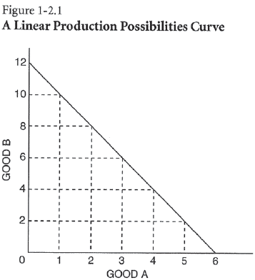
Assume the economy represented by Figure 1-2.1 is presently producing 12 units of Good B and 0 units of Good A.
  - The opportunity cost of increasing production of Good A from 0 units to 1 unit is the loss of ___________ unit(s) of Good B.
  - The opportunity cost of increasing production of Good A from 1 unit to 2 units is the loss of ___________ unit(s) of Good B.
  - The opportunity cost of increasing production of Good A from 2 units to 3 units is the loss of ___________ unit(s) of Good B.
  - This is an example of (constant / increasing / decreasing / zero) opportunity cost per unit for Good A.
Figure 1-2.2 contains a typical PPC often used by economists. This PPC is concave to the origin; it gets steeper as the country moves out along its horizontal axis. Use Figure 1-2.2 to answer the questions to the right of the figure.
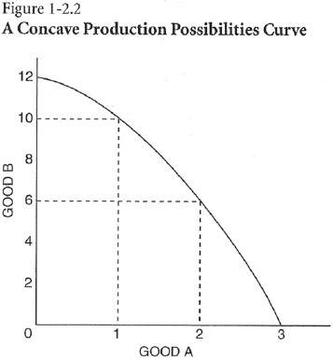
If the economy represented in Figure 1-2.2 is presently producing 12 units of Good B and 0 units of Good A.
  - The opportunity cost of increasing production of Good A from 0 units to 1 unit is the loss of ___________ unit(s) of Good B.
  - The opportunity cost of increasing production of Good A from 1 unit to 2 units is the loss of ___________ unit(s) of Good B.
  - The opportunity cost of increasing production of Good A from 2 units to 3 units is the loss of ___________ unit(s) of Good B.
  - This is an example of (constant / increasing / decreasing / zero) opportunity cost per unit for Good A.
Use the following axes to draw the type of curve that illustrates the label above each graph.

Increasing Opportunity Cost per Unit of Good B
Zero Opportunity Cost per Unit of Good B
Constant Opportunity Cost per Unit of Good B

Good A
Good B
Good A
Good B
Good A
Good B

Use the figure below to answer the next five questions. Each question starts with Curve BE as a country’s PPC.
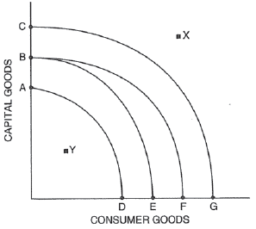
- Suppose there is a major technological breakthrough in the consumer-goods industry, and the new technology is widely adopted. Which curve in the diagram would represent the new PPC? (Indicate the curve you choose with two letters.) _____________________
- Suppose a new government comes into power and forbids the use of automated machinery and modern production techniques in all industries. Which curve in the diagram would represent the new PPC? (Indicate the curve you choose with two letters.) _____________________
- Suppose massive new sources of oil and coal are found within the economy, and there are major technological innovations in both industries. Which curve in the diagram would represent the new PPC? (Indicate the curve you choose with two letters.) _____________________
- If BE represents a country’s current PPC, what can you say about a point like X?

- If BE represents a country’s current PPC, what can you say about a point like Y?

- Why might a government implement a policy to move the economy away from consumer good and towards capital goods instead?

